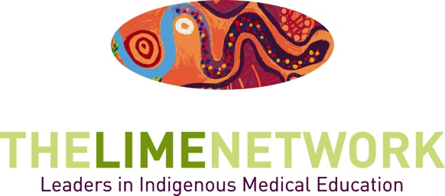

Slice of LIME Online Seminars - Background

About
The LIME Network hosts Slice of LIME Online Seminars on topics related to Indigenous health and health professional education. The seminars aim to contribute to sharing knowledge and strengthening capacity amongst the LIME Network membership.

The Slice of LIME Online Seminars have been developed to provide easily accessible and regular professional learning opportunities for LIME Network Members which complement other activities of the project, including the bi-annual LIME Connection Conferences.

Seminars are either hosted by the LIME Network (LIME Hosted Seminars) or co-hosted by the LIME Network and partner universities or organisations (LIME Supported Seminars).

Online Streaming and Recording
Seminars are streamed live on-line where possible, and recorded and uploaded to YouTube for later viewing.

All Slice of LIME Seminars can be viewed at:
W: limenetwork.net.au/resources-and-publications/slice-lime-seminars.

Roles and Responsibilities – LIME Supported Seminars

The partner organisation will:
- Submit applications at least one month prior to the event;
- Coordinate the location, date, speakers and any reading material for the event;
- Develop the event flyer and provide the opportunity for LIME to review it before it is distributed;
- Include the LIME logo on event flyers and notifications;
- Create the online stream and/or recording (including chat capability where possible), via their IT department;
- Send a link to the online stream for circulation to LIME Members;
- Promote the event to their networks;
- Cover any room hire, speakers, catering and other fees;
- Provide a file of the recording after the event for uploading to the LIME YouTube channel.

The LIME Network will:
- Work with the partner organisation IT department to set up the online stream and recording;
- Contribute to any online stream set up costs if possible;
- Email all LIME members about the event (2-3 weeks prior);
- Send a reminder email to all members on the day before or on the day of event;
- Put details on the front page of our website;
- Post on Facebook, Twitter and Instagram;
- Report on the event in the following LIME Network Newsletter;
- Host the video recording on the LIME Network YouTube channel.

Applications – LIME Supported Seminars

To link your event with the Slice of LIME Online Seminars, please submit an application form (on the following page), which will be assessed by the Slice of LIME Sub-Committee.

Requirements:
- The event topic needs to be relevant for LIME Network members, demonstrating a clear focus on the learning and teaching of Indigenous health in health professional education, and /or the recruitment and graduation of Indigenous health professional students.

- There is a two hour limit on seminar duration. If your seminar is longer than two hours, identify the session/s that will be selected for the Slice of LIME component, or indicate that editing will be undertaken.

- Applications must be received at least one month prior to the event to allow time the committee to assess applications, for promotional material to be disseminated and for IT requirements to be arranged.

The Slice of LIME Sub-Committee will consider alignment of the event to the following LIME Network objectives:
- Professional Development, Capacity Building and Support – Does the proposed seminar encourage LIME Network members and their colleagues to engage with and deliver initiatives in Indigenous health education?

- Professionalisation of the Discipline, Research and Evaluation - Does the proposed seminar encourage the development of Indigenous health as its own discipline by providing opportunities for networking, collaboration, and information sharing?

- Multi-sectoral Networking - Does the proposed seminar encourage LIME Network members and their colleagues to work collaboratively, build linkages and share information across disciplines in health professional education, Indigenous health networks, Indigenous communities and organisations, medical student representatives and other health education networks?

To determine if your event is suitable to be run as a Slice of LIME Online Seminar, please see the application flow chart on the following page.

Slice of LIME Online Seminars – Application Flow Chart
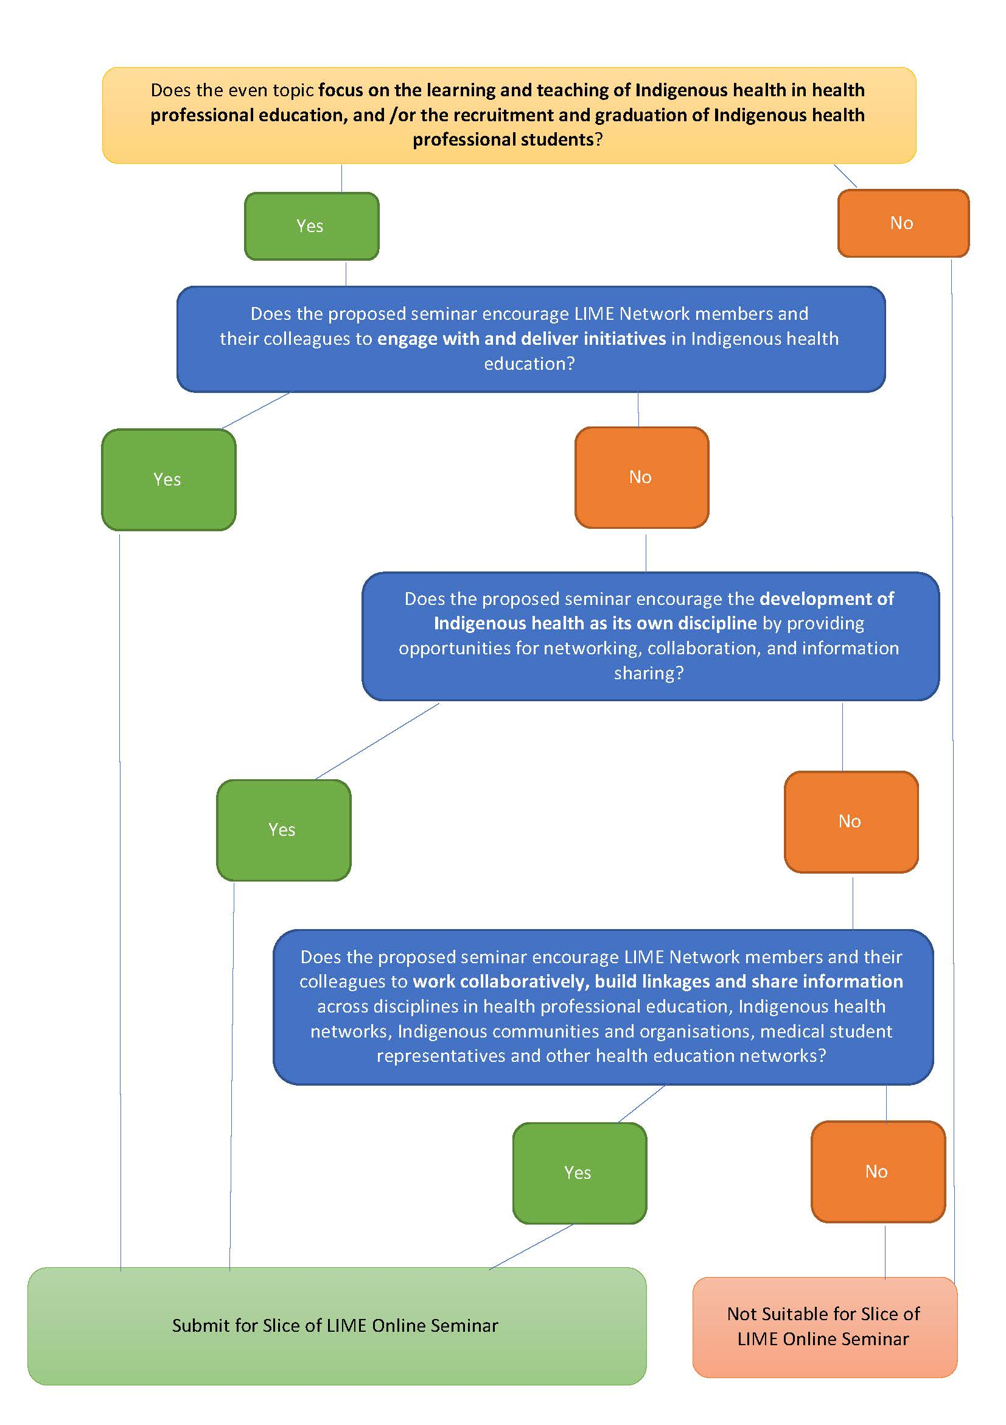

Slice of LIME Online Seminars - Application Form

Application
If you would like to link a forum or seminar with the Slice of LIME Online Seminars, please email the LIME Network and include all of the following information.

Note that the event topic needs to be relevant for LIME Network members, demonstrating a clear focus on the learning and teaching of Indigenous health in health professional education, and /or the recruitment and graduation of Indigenous health professional students.

Event information
- Event Blurb: Please include topic, format and key focus areas of the event.
- Event Title:
- Event Date:
- Event Location:
- Event Time:
- Event Duration (2 hour limit):

Requirements:
- Is the event topic relevant for LIME Network members, demonstrating a clear focus on the learning and teaching of Indigenous health in health professional education, and /or the recruitment and graduation of Indigenous health professional students? YES / NO
AND:
- Does the proposed seminar encourage LIME Network members and their colleagues to engage with and deliver initiatives in Indigenous health education? YES / NO

AND/OR:
- Does the proposed seminar encourage the development of Indigenous health as its own discipline by providing opportunities for networking, collaboration, and information sharing? YES / NO

AND/OR:
- Does the proposed seminar encourage LIME Network members and their colleagues to work collaboratively, build linkages and share information across disciplines in health professional education, Indigenous health networks, Indigenous communities and organisations, medical student representatives and other health education networks? YES / NO

Contact:
- Contact person
- Name:
- Organisation:
- Email:
- Phone:
- IT contact name and number (for online stream setup):

Event Format (seminar/forum/workshop/presentation etc):
- Estimate for number attending in person:
- Target Audience (eg students, educators):
- Is online streaming available? Yes/No
- Is video and audio recording available for later viewing? Yes/No
- Speakers:

Contact us via +61 3 8344 0813 for further information.

Please submit this form to lime-network@unimelb.edu.au

