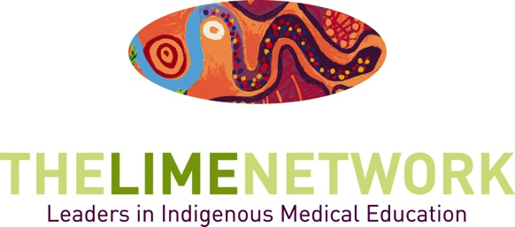

Slice of LIME Seminars

Background and Application Form

About
The LIME Network hosts Slice of LIME Seminars on topics related to Indigenous health and health professional education. The seminars aim to contribute to sharing knowledge and strengthening capacity amongst the LIME Network membership.

Seminars are often co-hosted by the LIME Network and partner universities or organisations.

Online Streaming and Recording
Seminars are streamed live on-line where possible, and recorded and uploaded to YouTube for later viewing.

All Slice of LIME Seminars can be viewed at:
W: limenetwork.net.au/resources-and-publications/slice-lime-seminars.

Roles and Responsibilities

The partner organisation will:
- Coordinate the location, date, speakers and any reading material for the event;
- Develop the event flyer and provide the opportunity for LIME to review it before it is distributed;
- Include the LIME logo on event flyers and notifications;
- Create the online stream and/or recording (including chat capability where possible), via their IT department;
- Send a link to the online stream for circulation to LIME Members;
- Promote the event to their networks;
- Cover any room hire, speakers, catering and other fees;
- Provide a file of the recording after the event for uploading to the LIME YouTube channel.

The LIME Network will:
- Work with the partner organisation IT department to set up the online stream and recording;
- Contribute to any online stream set up costs if possible;
- Email all LIME members about the event (2-3 weeks prior);
- Send a reminder email to all members on the day before or on the day of event;
- Put details on our website events page (http://www.limenetwork.net.au/views/events/events);
- Put details on the front page of our website;
- Post on Facebook and Twitter;
- Report on the event in the following LIME Network Newsletter;
- Host the video recording on the LIME Network YouTube channel.

Applications
To link your event with the Slice of LIME Seminars, please submit an application form, which will be assessed by the Slice of LIME Committee. Applications must be received at least one month prior to the event. The committee will consider alignment of the event to the following LIME Network objectives:
- Professional Development, Capacity Building and Support
Encourage Network members and their colleagues to engage with and deliver initiatives in Indigenous health education.
- Professionalisation of the Discipline, Research and Evaluation
Encourage the development of Indigenous health as its own discipline by providing opportunities for networking, collaboration, and information sharing.
- Multi-sectoral Networking
Encourage LIME Network members and their colleagues to work collaboratively, build linkages and share information across disciplines in health professional education, Indigenous health networks, Indigenous communities and organisations, medical student representatives and other health education networks.

Application
If you would like to link a forum or seminar with the Slice of LIME Seminars, please write to the LIME Network and include all of the following information:

Contact person
- Name:
- Organisation:
- Email:
- Phone:
- IT contact name and number (for online stream setup):

Event information
- Event Date:
- Event Location:
- Event Time/Duration:
- Event Title:

Event Format (seminar/forum/workshop/presentation etc): (This needs to be in an appropriate format and there needs to be the ability to stream and/or record the event.)
- Estimate for number attending in person:
- Target Audience (eg students, educators):
- Is online streaming available? Yes/No
- Is video and audio recording available for later viewing? Yes/No
- Speakers:
- Event Blurb:
Please include topic, format and key focus areas of the event. The event topic needs to be relevant for LIME Network members, demonstrating a clear focus on the learning and teaching of Indigenous health in health professional education, and /or the recruitment and graduation of Indigenous health professional students.

Contact us via +61 3 8344 9160 for further information.

Please submit this form to lime-network@unimelb.edu.au

Applications are due 1 month in advance of the seminar date.

